Roll Analysis
The length of the average shooter’s roll is 8.5
Craps Probability (casinocitytimes.com)

The most-frequent shooter tenure is 3 rolls
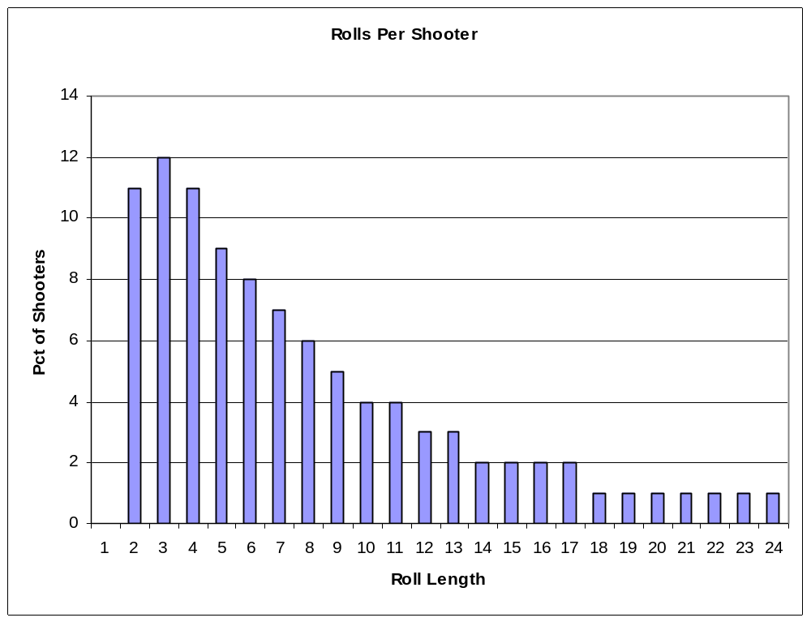

50% of shooters roll 6 times or less
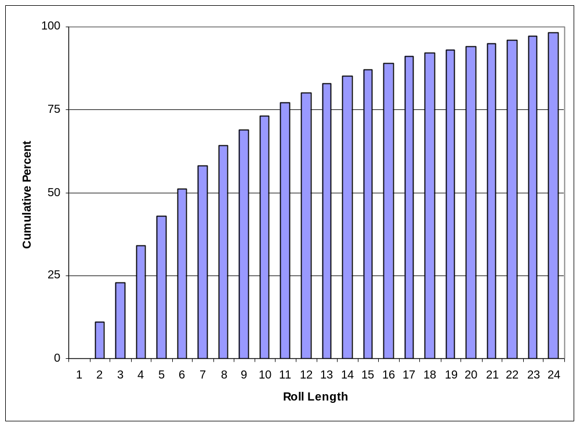
More than half of all rolls cover 3 or more points
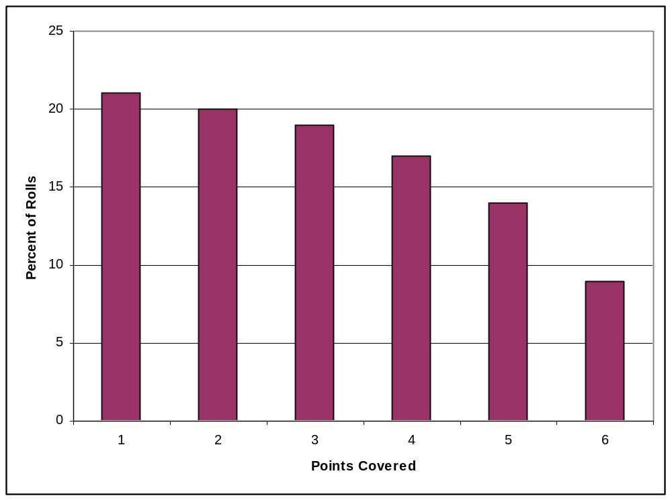

But almost half of all shoooters never even make their first & only point
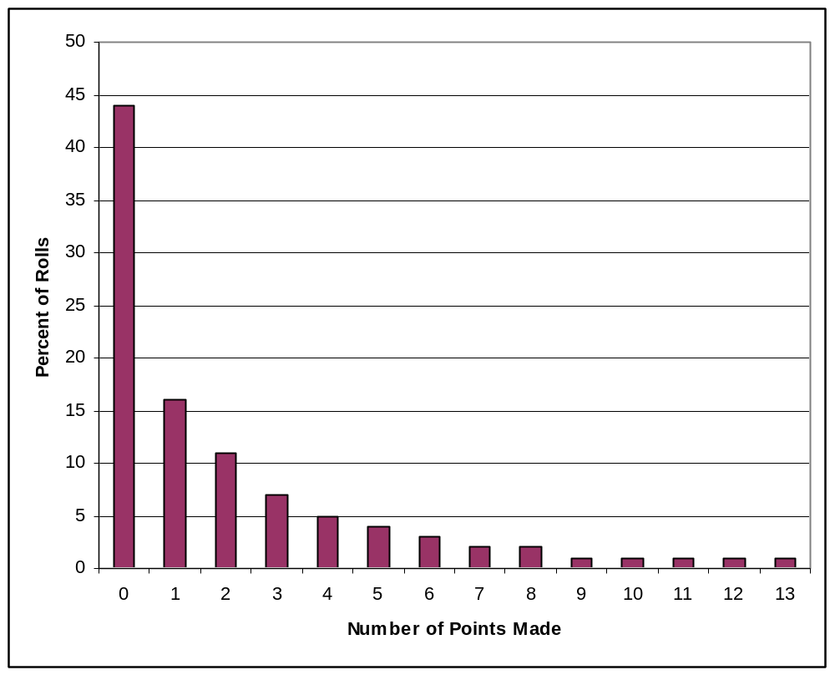

For a shooter who covers some number of points during his tenure,
here is how many of those points get made
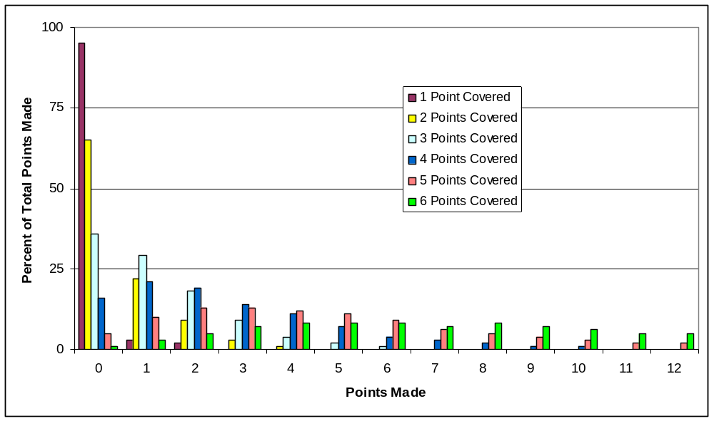

Number of points made is a linear function of roll length
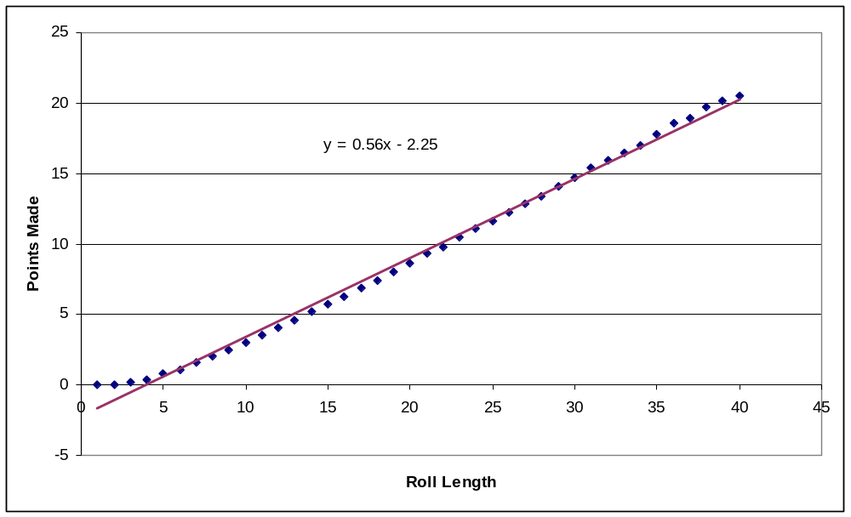
Baseline continuous come/don’t come betting of 1 unit
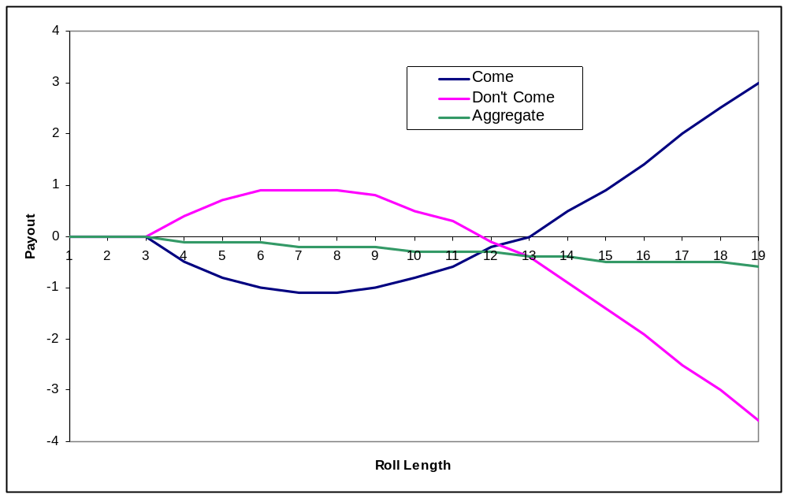

Aggregate win/loss when starting come bets earlier or later than don’t-come bets
